**Capstone Project (CPRO306)**

**Assessment 3: Final SRS Report**

**Project Title:** **Jot Bikes Management System**

|  |  |  |
| --- | --- | --- |
| **Team Members** | | |
| **No.** | **Name** | **SID** |
|  |  |  |
|  |  |  |
| **3** | **Hendra Lim** | **K220685** |
|  |  |  |
| **5** | **Thi Ngoc Quynh Ho** | **K220380** |

**1. Project Description 3**

1.1. Business Case 3

1.2. Purpose and Objectives 3

1.3. Detailed Scope 3

1.4. Proposed System Design Specifications 4

1.5. Methodology 4

**2. System Analysis and Requirements 5**

2.1. Software and Hardware Requirements 5

2.2. Functional and Non-Functional Requirements 5

2.3. User Requirements (use cases, use case diagram) 6

**3. Database Design 22**

3.1. Entity Relationship Diagram (ERD) 22

3.2. Data Flow Diagram (DFD) 23

3.3. Security Implementation 30

**4. User Interface Design 31**

4.1. User Interface Storyboard 31

4.2. Input Data Forms 36

4.3. Output Report Forms 37

**5. Test Plan & System Implementation Plan 39**

5.1 System Implementation Plan 39

5.2 Test Plan 39

**6. Feedback 40**

**7. References 40**

# 

# **1. Project Description**

## **1.1. Business Case**

## **1.2. Purpose and Objectives**

## **1.3. Detailed Scope**

* **Login and Registration**: Admins, Users and Vendors can login and register on JBMS (Jot Bikes Management System) by using secure and unique UserID/ email and password.
* **Manage:**
* **Vendor:** admins can update and view the vendors’ information, including add and delete them in the system.
* **Bike:** both admin and vendor can update and delete bikes’ information, however, only admin can add bike’s data such as: availability.
* **View:**
* **Booking:** both admin and vendor can view the booked products which had been done by the users.
* **Feedback:** admin can view the feedback from users and response.
* **Users:** admin can view the user’s information, including add, delete, and update
* **Users:**
* **Check bikes available:** user can check the number of products available for rent and sale, including search the products filters based on the specific brands, colours, price, etc.
* **Book and pay**: after browsing and checking all the necessary information, users can make a booking and pay online.
* **Encryption & Security:** some security features will be needed for this e-commerce website to protect the sensitive data and session cookies, such as: AES Security Encryption, firewall, SSL certificates, MFA, Payment Gateway, HTTPS.
* **Notification System:** the system will need notifications function for Admin, Vendor and User to remind them about the booking and payment to manage.

## **1.4. Proposed System Design Specifications**

## **1.5. Methodology**



# **2. System Analysis and Requirements**

## **2.1. Software and Hardware Requirements**

The hardware requirements for JBMS are:

* Processor: A CPU with window system with intel core i5 multicore processor (at least), recommended i7.
* RAM: A minimum of 8 GB RAM is recommended.
* External storage: An external hard drive will be included as a backup storage with 256GB minimum.
* Other tools: Keyboard, mouse, monitor, printer, and scanner.

The software requirements for JBMS are:

* Operating system: Windows 10 or later version for Window system and at least MacOS 13 Ventura version or later version for MacBook.
* MongoDB: MongoDB provides a free open source called Community Server, which will be used for this system.
* A compatible web browser: Web browser is Chrome and Microsoft Edge recommended or Firefox for Window system and Safari for MacBook.

A live server of JBMS can be accessed by the web browser after deploying.

## **2.2. Functional and Non-Functional Requirements**

The functional requirements for Management and others in JBMS are:

* Inventory Management:
* Tracking Bikes: users can search and filter their search results based on their requirements with accurate information about the products, such as: condition, colour, gear, size, availability, and model.
* Adding/ Removing Bikes: admins and vendors can easily remove and add products into the system for rental and sale based on the stock available.
* Inventory alerts: the system will alert admin and vendor when the stock is low or any products need to be maintained.
* Rental Management:
* Booking and scheduling: user can book online or through the system with specific date, time, and type of products.
* Rental agreements: rental agreements will include customers’ information, rental terms, bikes’ details, date and time, will be generated and stored in the system.
* Payment processing: the payment method – such as cash, credit, check, etc. – and data will be secured in the system.
* Rental check-in and check-out: provide an efficient check-in and check-out process, including product conditions and verify user information before and after processing.
* Extension of rentals: user can easily extend the rental if needed by itself through online and in-store system, also for vendor and admin.
* Sales Management:
* Product catalogue: products for sales or rentals discounts on specific will be displayed with details, visuals and price.
* Sale transactions: Any sale transaction will be processed and stored in the system, including payment and other fulfilment.
* Customer database: customers’ information, including personal, payment and historical and future transactions will be stored in the system.
* Customer Relationship Management (CRM)
* Customer Profiles: customer information – such as: contact details, rental history, and relevant information – will be maintained and stored in the system.
* Communications: customers will receive automated emails and notifications from the company regarding bookings, payments, newsletters and other relevant important information.
* Reporting and Analytics:
* Sales reports: sales reports, including popular types of products, revenue, customer demographics and sales performance, will be generated and stored in the system.
* Rental reports: rental reports are used to track rental activity of the company, including popular rental periods, customer preferable, occupancy rates and popular rental products.
* Inventory reports: demonstrate the fast, slow and non-moving (FSN) products, levels of stock and maintenance information of products.
* Other functions
* Integration with online booking platforms: customer can book products through online booking system of the website.
* User roles and permissions: implement different user roles with multiple levels of access to the system.
* Security: implement newest and necessary security features for the system to protect the customer’s data and other important stored information.
* Customization: software can be customized to meet the specific requirements of the company.

The non-functional requirements of JBMS are:

* Responsiveness: The JBMS will be responsive on various devices with different dimensions.
* Privacy: prevent customers’ data from being accessed by unauthorized participants.
* Security: Implement necessary and newest security features to protect the sensitive information and session cookies.
* Scalability: The ability of the system to expand in the future when the growth of users, transactions, products, vendors, admins and volume of data if the company upgrade to a bigger size.
* Reliability: the performance of the system needs to be consistency.
* Quality: the system is performing effectively and bug-free.
* Documentation: documents that involve in the project such as user and technical guidelines, and specifications.
* Response Time: how fast the company response to the users’ actions and requests for example: live chat, emails, phone calls, social media, etc.
* Maintainability: the system can be easily updated, developed, improved and expanded for the future needs.
* Performance: the response time, and resources’ quality demonstrate the effectively and efficiency of the JBMS.

## **2.3. User Requirements (use cases, use case diagram)**

The use cases of JBMS demonstrate how the users (such as: admin, vendor, and customers) and stakeholders are involved in the system.

**Admin**

* Create id & password

|  |  |
| --- | --- |
| CREATE ID & PASSWORD Use Case | |
| Name: | Create id & password |
| Actor/Role: | Admin |
| Description: | Demonstrate how to create the users’ account |
| Successful completion: | 1. Log into the system. 2. Go to Users section. 3. Choose a New User button. 4. Add new User details. 5. Click create. |
| Alternative: |  |
| Precondition: | Admin should have the details of the user |
| Postcondition: | Users are customers and vendors |
| Assumptions: | User does not have an account. |

Fig. Admin creating id & password use case

* Log into the system

|  |  |
| --- | --- |
| LOGIN Use Case | |
| Name: | Login |
| Actor/Role: | Admin |
| Description: | Demonstrate how admin log into the system through their account. |
| Successful completion: | 1. Admin log into and assess the system successfully. 2. Admin can view booking, users’ details and feedback in the ‘View Bookings’, and ‘View Customers’ section. 3. Admin can manage vendor and products information in ‘Manage Vendor’ and ‘Manage Bikes’ section. |
| Alternative: |  |
| Precondition: | Admin have their own username, and password |
| Postcondition: | Admin log in into the dashboard to manage vendor and products, also view users’ details and feedback, and booking. |
| Assumptions: | * Admin want to manage stock, vendor and check for booking and feedback. |

Fig. Admin login use case

* View bookings: View booked products.

|  |  |
| --- | --- |
| VIEW BOOKINGS Use Case | |
| Name: | View booking |
| Actor/Role: | Admin |
| Description: | Demonstrate how admin view the booked products. |
| Successful completion: | 1. Admin log into the system and access the "View Bookings" section successfully. 2. Admin view the list of booked products. 3. Admin can view the details of the bookings such as: start – end dates, number of booked products, type of products and customers details. |
| Alternative: |  |
| Precondition: | Admin should be logged in. |
| Postcondition: | Admin should be able to view the complaint. |
| Assumptions: | Customers booked the bikes. |

Fig. Admin view booking use case

* View Users and Feedback: view users details and their feedback

|  |  |
| --- | --- |
| VIEW USERS and FEEDBACK Use Case | |
| Name: | View Users and Feedback |
| Actor/Role: | Admin |
| Description: | Demonstrate how admin view the users’ details and their feedback. |
| Successful completion: | 1. Admin log into the system and assess ‘Customers’ section successfully that included the customer’s details and feedback. 2. Admin view the customer’s details and feedback after accessing the ‘Customers’ section. 3. Admin can update the users’ details and reply to the feedback (if needed). |
| Alternative: |  |
| Precondition: | Admin should be able to view the customers’ details and feedback. |
| Postcondition: | Admin should be able to reply to the customers’ feedback |
| Assumptions: | Admin receive feedback from the customers. |

Fig. Admin view customers’ details and feedback use case

* Manage Vendor: Admin can manage vendors information.

|  |  |
| --- | --- |
| MANAGE VENDOR Use Case | |
| Name: | Manage vendor |
| Actor/Role: | Admin |
| Description: | Demonstrate how admin manage vendor information |
| Successful completion: | 1. Admin log into the system and access the ‘Manage Vendor’ section successfully. 2. Admin view the details of all vendors. 3. Admin can update, delete and add vendors and vendors’ information. |
| Alternative: |  |
| Precondition: | Admin should be working for JB |
| Postcondition: | Admins can add or delete or update the vendor details. |
| Assumptions: | Vendors changed or vendor’s information has been changed. |

Fig. Manage Vendor use case

* Manage Bikes: Admin can update, add and delete products (information).

|  |  |
| --- | --- |
| MANAGE BIKES Use Case | |
| Name: | Manage Bikes |
| Actor/Role: | Admin |
| Description: | Demonstrate how admin manage the products. |
| Successful completion: | 1. Admin logs into the system and access the "Manage Bikes" section successfully. 2. Admin can view and check the bikes information and conditions. 3. Admin can update, delete and add the bikes information and conditions. |
| Alternative: |  |
| Precondition: | Admin are on shift while making any change. |
| Postcondition: | Admin can view, update, delete and add information and condition for bikes. |
| Assumptions: | Admin have access to the system. |

Fig. Manage Bikes use case

**Users**

* Registration: Sign up for member.

|  |  |
| --- | --- |
| REGISTRATION Use Case | |
| Name: | Registration |
| Actor/Role: | Customers |
| Description: | Demonstrate how the customer register to the membership |
| Successful completion: | 1. Customers access the registration page successfully. 2. Customers enter all the needed information (such as name, contact details, and address) through the registration form. 3. Customers submit the registration form and verify account through personal email. 4. The system creates an account successfully. |
| Alternative: |  |
| Precondition: | Customers should have all required details. |
| Postcondition: | Customers created an account with JBMS. |
| Assumptions: | Customers need to buy/ book any products from the shop. |

Fig. Registration use case

* Check Bikes Availability: Search for available products to buy/ rent.

|  |  |
| --- | --- |
| CHECK BIKES AVAILABILITY Use Case | |
| Name: | Check Bikes Availability |
| Actor/Role: | Customers |
| Description: | Demonstrate how the customers check the availability of the needed products |
| Successful completion: | 1. Customers access the Main Page successfully. 2. Customers search for products that they want based on colours, conditions, sizes, brands, etc. through filters. 3. Customers can check for the products availability before making any booking/ buying. |
| Alternative: |  |
| Precondition: | Customers should know what types of products they want. |
| Postcondition: | Customers should be able to find the bikes by using the filter and understand and accept its condition and information. |
| Assumptions: | Customers know what type of bikes they want. |

Fig. Check Bikes Availability use case

* Book and Pay: users can book and pay to rent the products.

|  |  |
| --- | --- |
| BOOK and PAY Use Case | |
| Name: | Book and Pay |
| Actor/Role: | Customers |
| Description: | Demonstrate how the customers book and pay for the products they want to rent/ buy on the website. |
| Successful completion: | 1. Customers will be led to the book and pay page after deciding the products they want to rent. 2. Customers fill the form with the payment information and agreements. 3. Customers click on the ‘book’ button and the system will save all the details and sent them to the admin dashboard. |
| Alternative: |  |
| Precondition: | Customers decided the products they want to rent. |
| Postcondition: | Customers are ready for booking. |
| Assumptions: | Customers are happy and understand all the conditions and information of the products. |

Fig. Book and Pay use case

* View Profile: customers can update personal information and booking (if needed).

|  |  |
| --- | --- |
| VIEW PROFILE Use Case | |
| Name: | View profile |
| Actor/Role: | Customers |
| Description: | Demonstrate how the customers can view and update their information in the system. |
| Successful completion: | 1. Customers log into the system and access the "Profile" section. 2. Customer successfully view their personal details and make any update if needed. 3. Customer can check and update their booking (if needed) directly on the website. |
| Alternative: |  |
| Precondition: | Customer should have an account and able to log into the system. |
| Postcondition: | Customers are able to view and update their personal details and bookings. |
| Assumptions: | Customers want to check their personal details and bookings. |

Fig. View Profile use case

* Log into the system

|  |  |
| --- | --- |
| LOGIN Use Case | |
| Name: | Login |
| Actor/Role: | Customers |
| Description: | Demonstrate how customer log into the system through their account. |
| Successful completion: | 1. Customer log into and assess the system successfully. 2. Customers can search and check the products availability. 3. Customers can book and pay for the products after satisfying with everything. |
| Alternative: |  |
| Precondition: | Customers have their own username, and password |
| Postcondition: | Customers log in into the dashboard where they can view and update their profile and booking. |
| Assumptions: | * Customers want to book/ manage personal or booking details. |

Fig. Customers login use case

**Vendor**

* Log into the system

|  |  |
| --- | --- |
| LOGIN Use Case | |
| Name: | Login |
| Actor/Role: | Vendors |
| Description: | Demonstrate how vendor log into the system through their account. |
| Successful completion: | 1. Vendors log into and assess the system successfully. 2. Vendor can view bookings and manage bikes in their dashboard. |
| Alternative: |  |
| Precondition: | Vendors have their own username, and password |
| Postcondition: | Vendors log in into the dashboard for viewing bookings and managing bikes. |
| Assumptions: | * Vendors want to view booking and manage products. |

Fig. Vendor login use case

* View bookings: View booked products.

|  |  |
| --- | --- |
| VIEW BOOKINGS Use Case | |
| Name: | View booking |
| Actor/Role: | Vendor |
| Description: | Demonstrate how vendor view the booked products. |
| Successful completion: | 1. Vendor log into the system and access the "View Bookings" section successfully. 2. Vendor view the list of booked products. 3. Vendor can view the details of the bookings such as: start – end dates, number of booked products, type of products and customers details. |
| Alternative: |  |
| Precondition: | Vendor should be logged in. |
| Postcondition: | Vendor should be able to view the complaint. |
| Assumptions: | Customers booked the bikes. |

Fig. Vendor view booking use case

* Manage Bikes: Vendor can update, add and delete products (information).

|  |  |
| --- | --- |
| MANAGE BIKES Use Case | |
| Name: | Manage Bikes |
| Actor/Role: | Vendor |
| Description: | Demonstrate how vendor manage the products. |
| Successful completion: | 1. Vendor logs into the system and access the "Manage Bikes" section successfully. 2. Vendor can view and check the bikes information and conditions. 3. Vendor can update, delete and add the bikes information and conditions. |
| Alternative: |  |
| Precondition: | Vendor are on shift while making any change. |
| Postcondition: | Vendor can view, update, delete and add information and condition for bikes. |
| Assumptions: | Vendor have access to the system. |

Fig. Manage Bikes use case

* + 1. Use Cases

**Admin**

Fig. Admin use cases

**Vendor**

Fig. Vendor use cases

**Customer**

Fig. Customer use cases

# **3. Database Design**

## **3.1. Entity Relationship Diagram (ERD)**

Fig. ER Diagram

Fig. Class Diagram

## **3.2. Data Flow Diagram (DFD)**

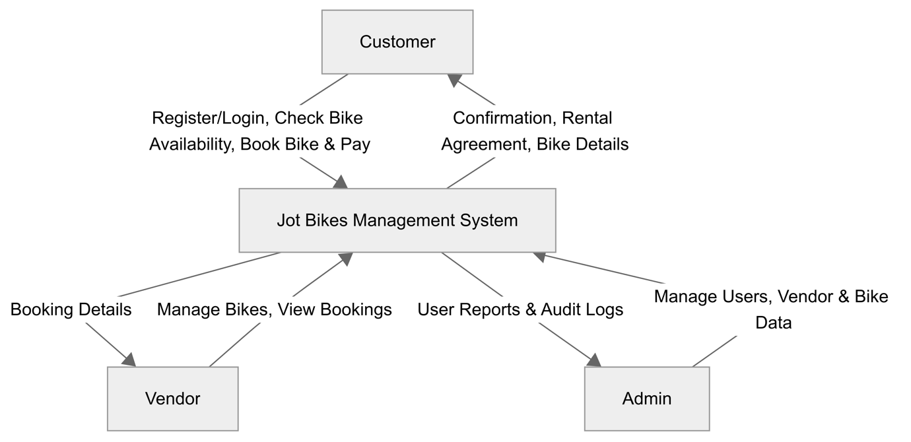

Fig. Data Flow Diagram Level 0

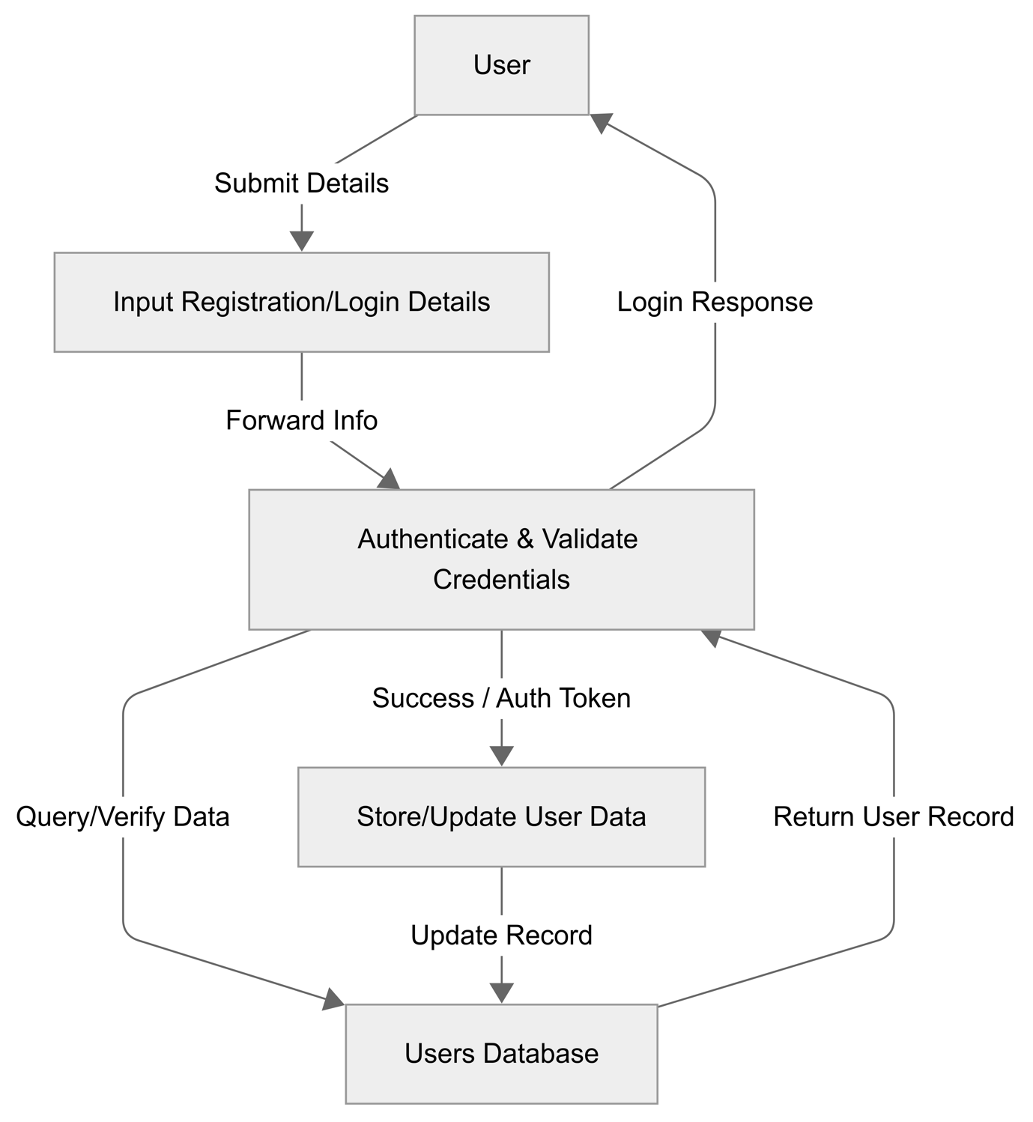

Fig. Data Flow Diagram Level 1 - User Registration and Login

Fig. Data Flow Diagram Level 1 – Check Bike Availability

Fig. Data Flow Diagram Level 1 – Book and Pay

Fig. Data Flow Diagram Level 1 – Vendor Manage Bikes

Fig. Data Flow Diagram Level 1 – Vendor View Bookings

Fig. Data Flow Diagram Level 1 – Admin Manage Vendor

Fig. Data Flow Diagram Level 1 – Admin Manage Bikes

## **3.3. Security Implementation**

CIA (Confidentiality, Integrity, and Availability) must be adhered to when designing and implementing a website. For Jot Bikes Rental Management System, a multi-layered security approach has been implemented. This system consists of BCrypt which is used for secure password hashing, AES-256 encryption for sensitive data, data anonymization for privacy-compliant analytics, and RBAC (Role-Based Access Control) to ensure user has access based on their assigned role. Additionally, following industry best practice as recommended by OWASP and NIST. Secure Communication (HTTPS/SSL), environment-based key management, and having a proper admin activity login for audit trail will also be implemented. Precaution has been taken to ensure that JBMS is compliance and resilience in an unlikely event of a security breach.

### 3.3.1 Password hashing using Bcrypt

All password in JBMS is stored using the BCrypt hashing algorithm as it is highly resistant to brute-force and rainbow table attacks. BCrypt adds automatic salting to prevent identical passwords having the same hash and it is supported by all major language and framework.

Implementation

* User password are hashed during registration using bcrypt.hashpw().
* The salted hash result is stored in the database.
* During login, the password is verified using bcrypt.checkpw().

### 3.3.2 AES-256 Encryption for data at rest

In this modern era, it is the utmost importance to safeguard sensitive user information or PII (Personally Identifiable Information) and payment metadate. JBMS will be using the AES-256 encryption as it is recognized globally for its strength and speed.

Implementation

* Data will be encrypted using AES-256-CBC algorithm via the backend.
* Ensure that decryption will only be permitted after role-based authentication is validated.

### 3.3.3 Data Anonymization for Analytic

To maintain user privacy, PII (Personally Identifiable Information) such as names, email addresses, and contact number must be anonymized. This is achieved through pseudonymization which will replace name with a coded identifier and email masking. Which will convert [K11111@student.kent.edu.au](mailto:K11111@student.kent.edu.au) to [K*****@student.kent.edu.au](mailto:K*****@student.kent.edu.au) , this will align with global data protection standards for privacy-enhancing data de-identification.

### 3.3.4 Role-Based Access Control (RBAC)

RBAC ensure that user only access feature that is relevant to their role

* Admin: Full access to the whole system
* Vendor: Access to the bike catalogue to add, update, and delete
* User: Access to their profile, manage booking, and provide feedback.

### 3.3.5 Additional Security Best Practice

With the evolving security landscape additional security measure will also be implemented to build a future-proof system.

* Secure Communication (HTTPS/SSL): network communication is conducted over HTTPS using TLS encryption to prevent any data leakage and interception during transit.
* Admin activity logging: administrative actions are being logged to ensure accountability, operational transparency and preparation in case of future audit.

# **4. User Interface Design**

## **4.1. User Interface Storyboard**

## **4.2. Input Data Forms**

## **4.3. Output Report Forms**

# **5. Test Plan & System Implementation Plan**

## **5.1 System Implementation Plan**

## **5.2 Test Plan**

# **6. Feedback**

# **7. References**